Final Project Design Phase
Computer Science - Week 11
Oct 3, 2026 - Version 0.0.4

For complete instructions and project ideas, refer to the assignment in Canvas. Specifically, review the final project requirements before you continue below. If you have not reviewed the project requirements in Canvas (you might have to go to the modules view and check the current or past week's content), you will not be able to properly complete the parts below. In addition, it may be helpful to review the information on this Drafter documentation page.

0) Project Planning and Preparation
Successful programmers spend time planning before they begin coding. After reviewing the project requirements, answer the following questions to help guide your design and development process.
- What concepts from class or previous assignments might help you complete this project? Which programming concepts (loops, conditionals, lists, classes, etc.) do you expect to use? What programming skills do you want to improve while completing this project?
I will have to use at least 7 routes, 5 pages, 4 fields in State, 3 input fields, 3 if statements, 1 loop, and the drafter library. During this project, I will further my proficiency in drafter.

- Which parts of the project do you expect to be the easiest for you? The hardest? Why?
I think the easiest part of the project will be using AI to code for me. The hardest part will be taking that code and modifying it to do exactly what I need, because I will have to fully read through and understand what the AI’s code is doing.

- Even though you have not yet designed the final project, estimate which tasks will likely require the most time and effort? Which features or components should be implemented first?
I think the most time will be allocated to making sure I meet all the project requirements in my code. It will take a while to read through the code the AI gives me, and make sense of it. The features that should be implemented first are the basics: the variables that I need to solve my problems.

- What distractions might interfere with your work and how will you minimize them? What resources will you need available while working? What questions, if any, do you still have about the assignment requirements?
The fact that we can use AI will make me feel like I don’t need to get so far ahead with my work, which isn't good. I will minimize this by getting ahead on my work.

1) Site Diagram
Create a mock-up of your planned website. We suggest you make the mockup on paper, although you can also use software like PowerPoint or Slides to make a mockup. There is other design software that could also be used, but we strongly encourage you to keep it simple. Do not spend more than 15-30 minutes detailing the mock-up. Your goal should be to make a very quick and dirty diagram, to show that you have some kind of idea.

We recommend drawing each page as a rectangle, and laying out the text, buttons, and other components inside. Then, use arrows to indicate links between pages. Label each page the way you will name each function, and then put labels on the arrows to indicate what the button links. Also write down any parameters that should come into the pages.

In addition to the pages and routes, write down what fields your `State` will have, both their names and types. Think clearly about what data will need to be persistent across the entire website.

Add photo(s) or screenshot(s) of your website mock-up and labeled diagram on the next page.

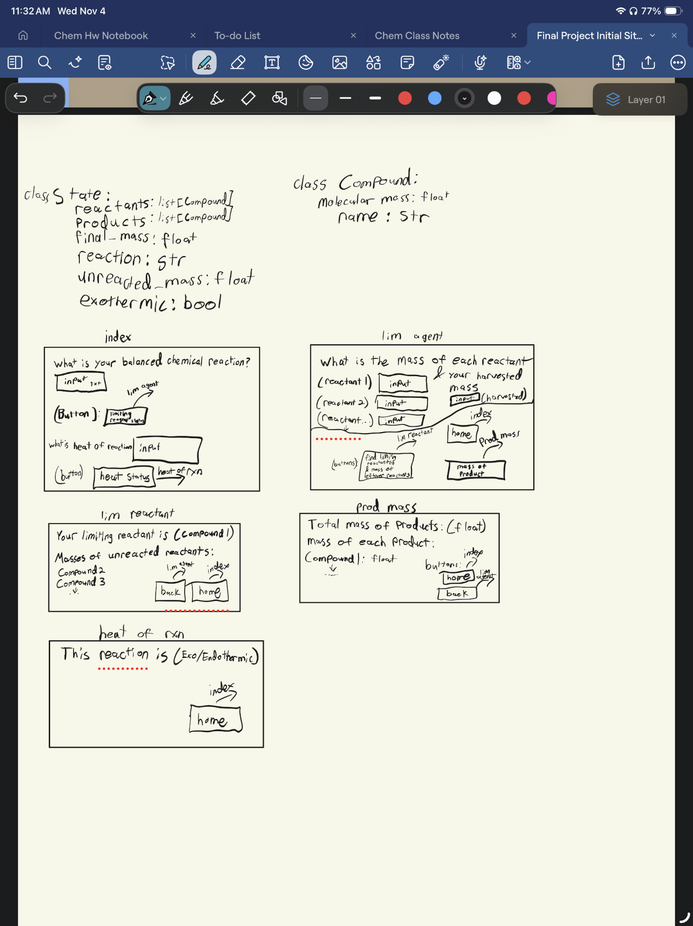
2) Implementing Requirements
This table should serve as a draft for how you will implement the requirements into your final project. You may change your ideas later on, but your final site must fulfill all the requirements.

Requirement | Implementation
Purpose/Functionality  A 1-2 sentence description of the purpose or functionality of your site | This project takes balanced reaction equations, starting reactant masses, and a harvested product amount to determine the limiting reactant, theoretical yield, and percent yield. It produces an organized breakdown of limiting reagent status, product yields, and remaining masses of unreacted species.
State Dataclass Attributes  Minimum of 4 attributes, one of which must be a list/dict of instances of your second dataclass.  Briefly describe each attribute, its type, and how it will be meaningfully modified throughout the site. | Class State:  Reactants: list[Compound] (changes with reaction)  Products: list[Compound] (changes with reaction)  Final_mass: float (changes with reaction)  Reaction: str (changes with reaction)  Unreacted_mass: float (changes with reaction)  Exothermic: bool (changes with reaction)
Second Dataclass  Your second dataclass, including its attributes, their types, and how they will be meaningfully modified (if they are modified) | Class Compound:  Name: str (changes with compound)  Molecular_mass: float (changes with compound)
Routes (minimum 7)  The names of your route functions | Find_lim_agent  Find_heat_of_rxn  Find_product_mass  Index  Mass_of_unreacted  Previous_page  heat_flow_per_mole
Pages (minimum 5)  A brief description of the pages in your site | Lim agent(takes masses of reactants)  Lim reactant(finds limiting reactant and masses of leftovers)  Prod mass(finds total mass of products and mass of each product)  Heat of rxn(finds out if the reaction is exo/endothermic)  index(allows input of balanced chemical reaction)
User Input (minimum 3)  Description of user input components (TextBox, TextArea, CheckBox, or SelectBox) and their purposes  For more information on these input types, see Drafter Documentation. | Textboxes:  - What is your balanced chemical equation?  - What is your heat of reaction  - Mass of reactant 1,2,3…  - What is your harvested product mass
If Statements (minimum 3)  Brief description of what will be evaluated in your if statements and how they will meaningfully change the logic of the site | If the heat of reaction is negative, then the exothermic field in state will be true, and will be false if the heat of reaction is positive.  If the harvested mass is larger than the predicted, then there was a problem with the experiment.  If the moles of reactants are equal and all coefficients are one, there is no limiting reactant.
Loop (minimum 1)  This loop must iterate over the list/dict of dataclass instances in your State attribute.  Description of this loop and why it is meaningful to the site | This loop will iterate over the list of compounds in the equation by splitting by ‘+’ and make it into a list of compounds.

LLM Conversation
If you used an LLM in any part of this work, copy and paste every part of that conversation below. Otherwise, you may be given a zero for the assignment. Obviously, these words will not all be yours, and this is the exception to the requirement at the top of this assignment that all responses be in your own words. If you did not use an LLM to assist you in this assignment, simply say so below.
Replace this text with your answer.

Final Submission
When you are finished, download this file as a Word Document (docx) and upload the file to the appropriate assignment on Canvas.

